

EAST CHESHIRE BASKETBALL COMMUNITY INTEREST COMPANY (CIC)

CLUB DEVELOPMENT PLAN

JUNE 2026

CONTENTS
- Executive Summary
1.1 Who are we?
1.2 What do we aim to achieve?
1.3 What are our key priorities for the next 1, 2 and 5 years?
1.4 Our identity and value proposition

- Club Vision, Mission & Values
2.1 Our vision
2.2 Our mission
2.3 Our values

- Club Profile and Current Situation
3.1 Snapshot of club today
3.2 S.W.O.T Analysis

- ECB - Seven Strategic Pillars
4.1.
a Entry Programmes (u8s/u10s)
b Youth Development (u14s/u16s)
c Senior Proposition (u18s/18+)
d Talent identification
e Annual training plan and periodisation
f Miscellaneous Additions
4.2.
a Coaching Structure
b Qualification levels and development
c CPD pathways
d Recruitment strategy
e Performance reviews and philosophy building
4.3.
a League entries and affiliations
b Competition Schedule
c Internal Competitions
d Performance Targets
e Travel and logistics planning
4.4.
a School Partnerships
b Camps and events
c Outreach programmes
d Fundraising and collections
e Local authorities and information

4.5.
a Venues and access
b Equipment inventory and plans
c Long term facility goals and development
d Opportunities for venue partnerships
4.6.
a Current income streams
b Financial projections
c Sponsorship packages and targets
d Risk management and data
4.7.
a Brand guidance
b Website and online presence strategy
c Content plan and outline
d Communication Policies Internal/External

- Club Culture & Welfare
5.1 Safeguarding and reporting
5.2 Codes of conduct
5.3 Behavioural Policy
5.4 Inclusion and Diversity plan
5.5 Mental Health Support

- Governance & Club Management
6.1 Current structure and positions
6.2 Roles and responsibilities
6.3 Decision making process
6.4 Review cycle
6.5 Legal compliance

- Strategic Development Roadmap
7.1 Year One
7.2 Year Two
7.3 Year Five

- Key Performance Indicators and Success Measures
8.1 Membership Targets
8.2 Infrastructure Targets
8.3 Performance Targets
8.4 Financial milestones
8.5 Online presence projections
8.6 Facilities improvements

- Final Word and Summary

- Appendices

1. Executive Summary

1.1 Who are we?

East Cheshire Basketball CIC is a newly structured version of a former non-profit, based in Cheshire East that has offered basketball provision for a variety of members for a number of years. The club started in the 1960s with a number of stewards throughout the decades, under the moniker Congleton Grizzlies. The club has won awards over the years, had former MP backing and provided a key outlet for many residents of the local town. After the covid pandemic, the club went through a modernisation period in which it became a founding member of the North West Regional Development League and the We Got Next basketball league, and has previous proposition for Mens, Womens and junior provisions.

1.2 What do we aim to achieve?

With our restructure and rebrand, we have refocused our offering and target three main aims:
- To increase participation in sport using basketball as a medium in our county.
- To diversify the proposition available to our residents allowing them to choose how they get involved, with clear pathways in place allowing for more driven members to progress to the elite level.
- To increase the knowledge of the sport and its health benefits with local partnerships, schools, local charities and other entities deemed beneficial to our cause.

1.3 What are our key priorities for the next 1, 2 and 5 years?

We will outline some key points within a 1 year, 2 year and 5 year timeline below, with specified intervention dates to review our offerings, compare to this plan and put into place any changes to guide us to achieving our targets. We will provide a SWOT analysis of the offering as it stands presently, with SMART goals advised for each of the aforementioned time periods.

1.4 Our identity and value proposition

With our new identity and structure, we believe it provides us a unique offering in our area which is starved of basketball options, unifies the area under one strategic proposal and in turn will grow the proposition for all residents within Cheshire East. Within our CIC, we have three ‘arms’ of operation. See below for more detail.

- East Cheshire Knights Basketball
  - The competitive arm of the CIC. This contains our development sessions and our competitive league teams as well as our open community sessions. All basketball related activity is under the direction of the Technical Performance Lead.

- East Cheshire Community Basketball League
  - The in-house league is designed to recruit, develop and qualify new coaches, officials and staff. Operating once a month with varying age groups, this allows us to offer a ‘try before you buy’ for each official role to volunteers and potential recruits in a safe, development based environment, whilst also centralising the location for players to play organised basketball for the reason of development and talent identification. This arm is directed by the league chair.

- Cheshire East Basketball Initiative
  - The off-court arm of the CIC, managing the online presence of the CIC and other arms, the fundraising and community aspects as well as strategic partnerships and sponsorships with the community. Access to schools is also managed through this arm under the direction of the Club Secretary.
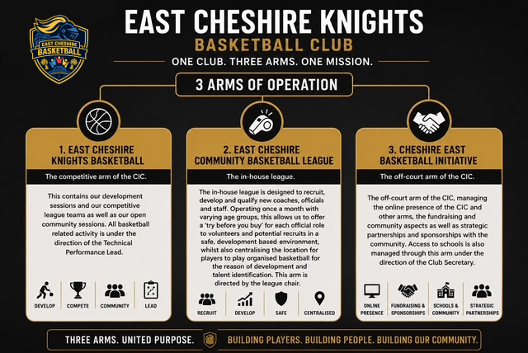

2. Club Vision, Mission & Values

2.1 Our Vision

The organisation exists to grow basketball across Cheshire East by providing accessible opportunities for people of all ages, creating clear development pathways for players, coaches, referees, officials, and volunteers, and delivering safe, inclusive, well‑run sessions, leagues, and events. It aims to build a positive community built on Attitude, Commitment, and Excellence, support talented individuals to progress into higher‑level basketball, and work collaboratively with schools, clubs, community groups, and local authorities to strengthen the sport across the region. We aim to provide professional, inspiring, and inclusive basketball experiences from ages 6 and upwards across Cheshire East, increasing participation and expanding the opportunities available to all, all whilst educating our members about the wider health benefits of long term involvement in sport. 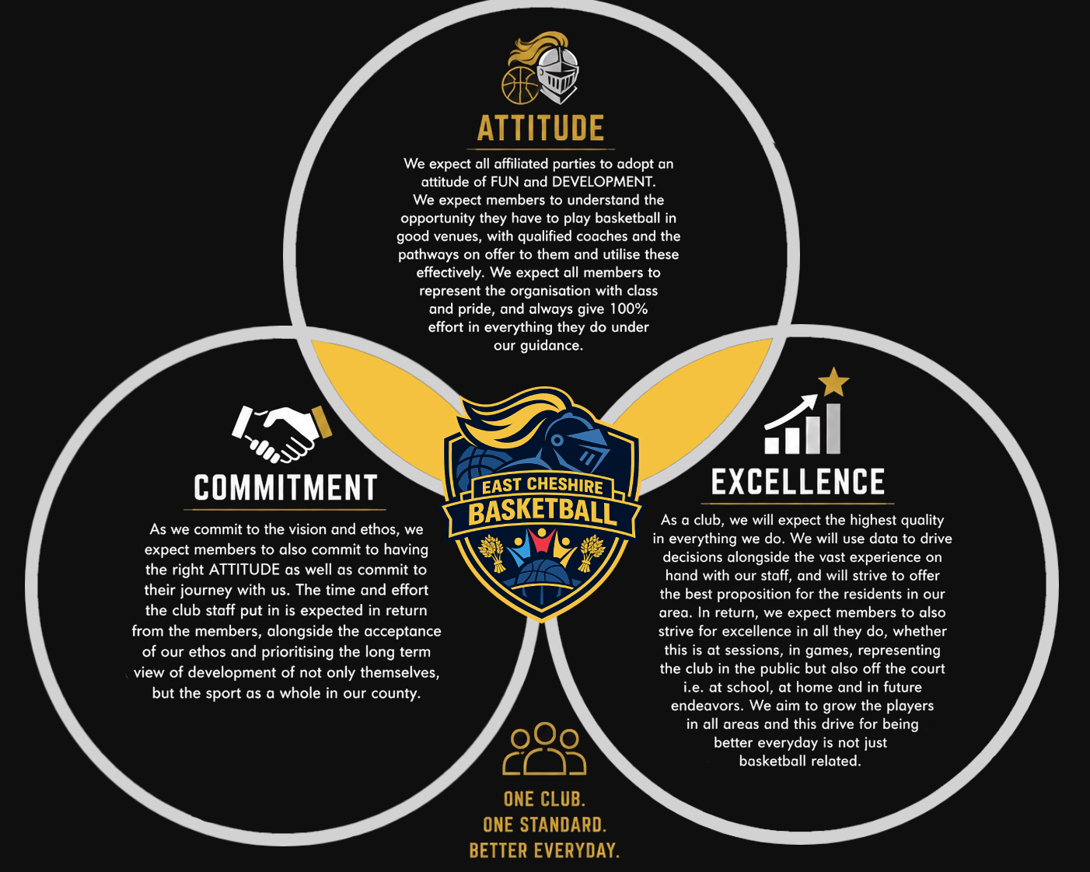

2.2 Our Mission

The current offering for the club involved weekly community sessions open to ages 6 and up based at a site in Congleton. We also offer closed team-training sessions for members of competitive teams entering an official league licensed by Basketball England. Our ‘community’ sessions offer introductions to skills, and easy to follow development cycles to maximise efficiency, but also offers a large allocation to open play within sessions to emphasise the ‘Basketball as a game’ view from our governing body, which in essence is based around the sport simply being FUN to play. Our team training sessions offer a more in-depth view into competitive basketball, utilising the Player Development Framework as a guide to ensure our players understand the basic concepts of competitive basketball and their roles within a team in a competitive format. All our sessions are planned for the long term development of each member, with development being prioritised over extrinsic successes.

2.3 Our Values

We as a club have high expectations for all of our members, whether they are players, parents, volunteers or staff. We operate on a view of aiming as high as possible to allow for constant growth, with a safety net of landing higher than expected should we fail. We accept failure as part of the development process for all involved, and have a simplified ethos all members should abide by and aim to grasp.

3. Club Profile & Current Situation

3.1 Snapshot of the club today

The club used to be known as Congleton Grizzlies Basketball Club. Offering basketball sessions to all ages and abilities, we managed to grow to 150 members in the 2022-23 season, with the last season obtaining 86 members attending sessions on a weekly basis. We operated sessions for u10s, u12s, u14s, u16s and u18s members after regretfully removing our seniors provision. We currently have 5 qualified coaches to level 2 standard, with multiple trainees at level 1 or on a course to obtain this award. We are based at Congleton High School, and have previously used Eaton Bank Academy, Congleton Leisure Center and Kidsgrove Leisure Center. We were structured as a non-profit, and are currently in-process of becoming a fully registered community interest company and listed on the Company's House. We are financially sound with data driven processes in place to ensure sustainability and fair costs for usage, with all changes under scrutiny and approval of a three-person board.

3.2 S.W.O.T Analysis
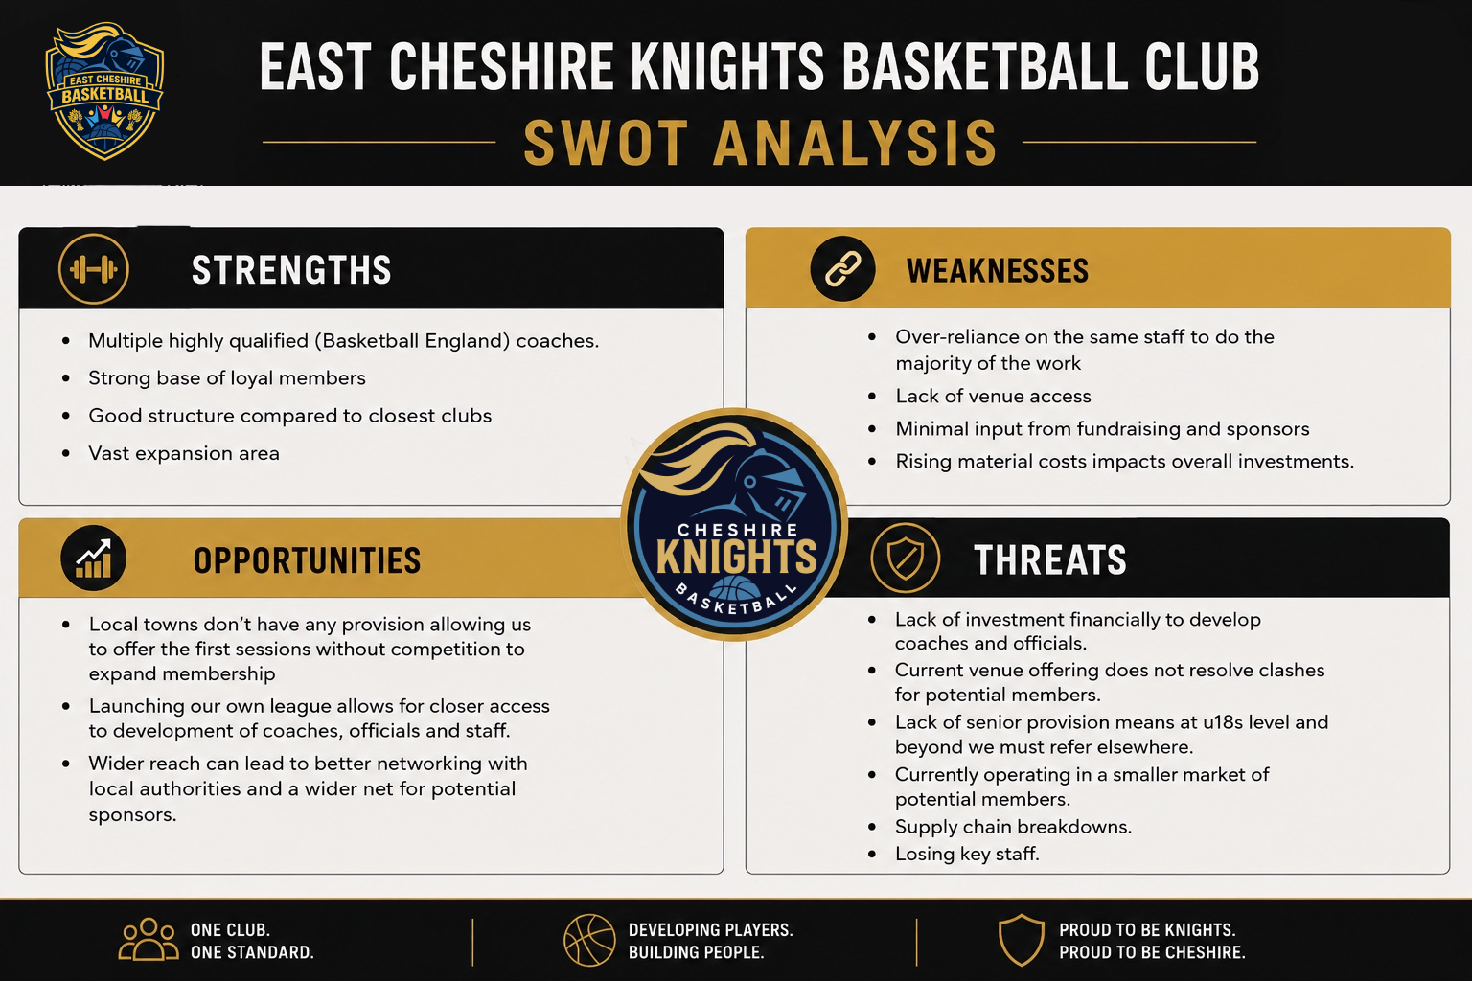

4. East Cheshire Basketball 7 Strategic Pillars

We have 7 Pillars to adhere to when we look at what the club entails. These Pillars prop up our offering to residents and members and enable us to ensure we stay aligned to our future plans.
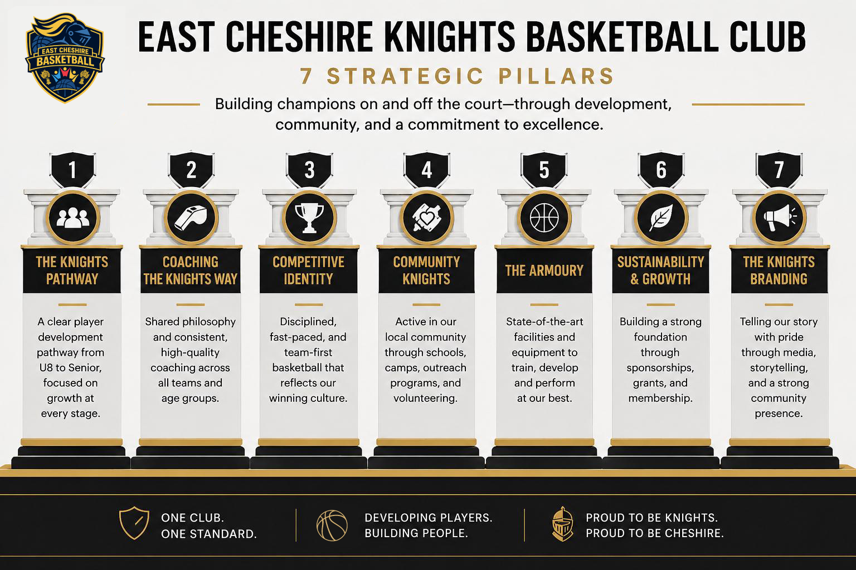
4.1 The Knights Pathway & Development
4.1.a Entry Programmes (u8s/u10s)
Our proposition starts from age 6 and upwards, as this is the earliest age we would expect a member to hold basic co-ordination and balance skills. This will still need to be developed long term, however these sessions will be heavily focused on these physical skills.
Sessions will aim to engage members with the sport at a very basic level, not using ‘skills’ as a foundation for planning, but focusing on fun, small group activities with an emphasis on Commitment, Teamwork, Empathy and Respect.The sessions will have minimal structure to allow freedom to explore the game whilst development fundamental baseline attributes that set them up for long term development.
4.1.b Youth Development (u12s/u14s/16s)
This stage of the pathway transitions from the entry level focuses and starts to introduce more in-depth activities and skills that will be translatable to game based activities. The u12s age group is the transition age to introduce these skills and build a foundation of expectations of sessions, with emphasis on translatable skills to the older ages.
U14s and u16s will introduce games-based principles, moving away from standard skill development to application of previously build skills in game-like scenarios. A shift of format will also take place, with members being provided individual development plans to continue skill development away from structured sessions, allowing for the structured sessions to focus on the activities that require multiple participants and more games-based activities.
We focus on Adaptability, Dedication and Patience at this age range, as not only will they be navigating basketball related changes, but also physical, educational and emotional changes away from the court.
4.1.c Senior Proposition (u18s/18+)
This age range adds specialisations and incorporates all previous learnings into a full programme for the members to lean on in future basketball activity. With physical attributes now emerging into final forms and the mental capacity increasing due to age and experience, the sessions will be advanced and more tactical than exploratory.
Focus shifts from skill development to being able to apply the learned skills at the required level of intensity and competitiveness whilst also cementing the members’ understanding and creativity within the game. We also add focuses on Resilience and Responsibility, which align with life events at this age. Jobs, social connections and further education all have an impact on basketball activity, meaning we need to monitor volume and intensity of sessions as well as provide effective targeting of activities to maximise the sessions.
4.1.d Talent Identification
Each member will be assessed against a unique skills matrix to aid in monitoring development at key points throughout the year and beyond. This skills matrix will feed into our data-led decision making process where we refer players to the NGB talent pathway.
We will also hold regular ‘Development’ sessions which will mirror the talent pathway so as to provide the best preparation for our members when they are referred to the programme.
Our internal CBL will also provide an option to identify talented members as it centralises the members to one venue in a competitive environment, allowing us to assess ability levels against other members who may have similar skills matrix scores.
4.1.e Annual Training Plan and Periodisation
The club will have an annual plan designed to provide a universal structure for all ages and venues, which allows us to ensure all members regardless of coach, venue or ability get the same access to each skill development cycle. This plan will be divided into Macro and Micro cycles in a block training model, to ensure maximum retention and available time to build up the abilities of the members. This will be readily available to all members of the coaching staff for reference.
4.1.f Miscellaneous Additions
We will continually assess the local, regional and national landscape for opportunities and developments to maximise opportunities to plan, complete and develop. This includes collaboration with other clubs, entry into pop-up events and competitions as and when available.
4.2. Coaching the Knights Way & Workforce Development
4.2.a Coaching Structure
All coaches will be registered with the governing body, and fully safeguarding compliant. Coaches will be allocated a role and venue which utilises their abilities and previous experience in the best way for the overall club. Coaches will be required to coach at least two hours per week in a development role, and can opt to take on a competitive team each season based on availability.
Coaches will start as Level 1s, and all level 1 coaches will be listed as Skills Coaches. These coaches will be the main runners of the community sessions and be provided with ongoing support each month to ensure their own development, with a view to placing them on a level 2 course with our NGB.
Level 2 coaches will be listed as Progression Coaches, providing a clear difference to level 1 coaches, but with added focus on the pathway the members will take whilst being able to provide guidance as Head Coaches for the competitive teams. These coaches will have a lead role in shaping the session plans within the microcycles and also be tasked with using the skills matrix to assess the members.
4.2.b Qualification Levels & Development
All our coaches will be provided with a structured development plan which outlines their current strengths and weaknesses, and identifies opportunities for their growth. Each coach will also be supported with drop in sessions and 1-2-1s which will provide feedback on observations as well as actions to continue their progression. Coaches will also gain access to our shared drive of session plans and online content to give them a rounded background of activities and examples to draw from when planning their sessions.
4.2.c CPD pathways
All coaches will be expected to develop their coaching practice through a variety of means. This could include wider reading, attending workshops, collaboration with other coaches/clubs as well as providing their own support to lower qualified coaching staff members.
All coaches will be provided with a vast array of opportunities to grow and get qualified to higher standards, with all barriers removed as much as possible within the remit of the club. Any coaches who wish to remain at their current standard will be accepted with clear plans in place to ensure their practice remains at a high standard throughout their affiliation with the club.
4.2.d Recruitment Strategy
Coaches for our club will be recruited in many ways. The main route for coaches to be affiliated with the club will be via entry pathways within our CBL. By using this to allow volunteers to get hands-on experience coaching games, we can support them in their initial take-up of the role and develop them to be solid, reliable Development Coaches.
Secondary routes for coach affiliation will involve mergers with other clubs/teams. Should another club in our region wish to join the ECB initiative, there will be a predefined set of criteria needing to be met between both parties before a merger can successfully take place. At this stage is when coaching qualifications, safeguarding documentation and previous experience will be obtained, and only after this will a new coach be allocated a role within the organisation.
Safer Recruitment guidelines will also be followed at each stage, with internal/merger/external applicants all being subject to DBS checks, knowledge checks and (depending on the circumstances) an informal/formal interview process.
4.2.e Performance Reviews and Philosophy Building
In line with NBG guidance, coaches will all be expected to take on an active role in their personal development and will be guided by our own development pathways and support projects.Coaches will be supported not only in their delivery of content, but also in building their own ideologies and philosophy of playing, with a view to obtaining level 3 certifications and beyond.
Performance reviews will take place at designated points in the year. These will be bi-annual, with the in-season review around the Christmas break, and an end of season review after the season ends in April. These reviews will follow a simple structure, be outlined before the 1-2-1 sessions and a full feedback form will be provided to the attending coaches. All reviews will be recorded for development purposes.
4.3. Competitive Identity and Strategy
4.3.a League Entries and Affiliations
The club will continue to be affiliated with the North West Regional Leagues, of which we are a founding member under the previous moniker, Congleton Grizzlies. We will also continue to have strong links with the We Got Next Basketball League hosted in Stoke-on-Trent, of which we are also a founding member.
The club will strive to provide a Junior NBL entry at each available age group in the years to come, but at this stage we do not have an entry into this competitive structure. We believe players should have the opportunity to play however so should we not enter this level at a relevant age group, but we do have a player we believe is of the standard, we will refer to another club to ensure opportunities are available and give the player and their family the choice.
Our long term vision is to hold teams at each level of Junior NBL and the NWRL, across all ages including girls entries.

4.3.b Competition Schedule
League schedules are available via PlayHQ/HoopsHQ and will also be posted on our website per team at the start of the season.
The club reserves the right to rearrange fixtures throughout the season to ensure the maximum number of games are played and to prevent forfeits.
4.3.c Internal Competitions
As part of our development initiatives, diversified playing portfolio and coaching recruitment strategy we will be running our own internal community league. This will allow us to centralise the players for talent identification purposes, recruit new staff as well as control the development progress of all our members.
4.3.d Performance Targets
All teams will prioritise DEVELOPMENT over final scores of competitive fixtures, however we appreciate that this view is not shared by most. We aim to win at least 25% of our fixtures at any age, whilst ensuring a fair distribution of minutes based on players abiding by our club ethos.
4.3.e Travel and Logistics Planning
All members and their families are committing to be a part of a team and as such this involves travelling to venues for away fixtures and events. Where possible, the clubs will employ Team Managers to manage match day attendance and provide key information relating to venue details and will liaise with the teams Head Coach to ensure this information is correct. Where a Team Manager is not available, this falls to the Club Secretary to ensure this information is readily available via our booking platform as well as links to HoopsHQ which will also hold valid information.
Future planning will also involve the clubs use of minibuses for team transport, however this is subject to driving qualifications, insurance and financial capabilities.
4.4 Community Engagement and Schools Partnerships
4.4.a School Partnerships
Our outreach area contains a large number of schools at varying key stages of education. As we offer a service from ages 6 and up, we need to be aware of the Social, Emotional and Mental Health of our members and how our proposition affects the members in their every day lives. Collaboration with all schools in our area will be beneficial in a multitude of ways.
We can offer higher level tutoring to the staff of the schools to ensure better basketball-related lessons, as well as liaising with potential sponsors/partners who also have offerings that could have beneficial effects within education.
Facility upgrades will also be largely beneficial, as the schools will use the facilities and equipment more than we would throughout the school days, and as such investment in this area would be hugely complimentary to the users.
We can also learn from the schools by understanding their development policies, strategies for teaching and learning as well as adhering to the teaching standard when we coach, ensuring a smoother transition from teacher to coach for our members.
4.4.b Camps and Events
The UK offers a vast range of camps for members to attend, which will benefit our members both on and off the court. We will aim to have proactive dialogue with these camps, obtain all the information required about the camps themselves including due diligence so we can provide a comprehensive list of whats on offer for our members.
We will also be looking at running camps and special events in half terms and throughout the year to widen and expand our offerings and provide new experiences to the membership base.
4.4.c Outreach Programmes
As a community based initiative we aim to provide a wider proposition for our members relating to basketball activity, however we also recognise that we need to sit alongside other offerings to provide opportunity, not to detract from other offerings available in our area. We will liaise with the relevant parties/business to ensure a collaborative approach, as well as provide enrichment opportunities to our members that they otherwise may not usually be subject to experiencing.
4.4.d Fundraisers and Collections
The company will be looking at running an array of fundraising activities in order to maximise investment into the organisation, enabling us to reinvest funds to designated areas of need. These will range from larger projects with match funding to smaller projects aimed at raising funds for specific purposes.
Collections will also be made at all fixtures for local charities and initiatives we believe need highlighting to ensure their continued growth, as well as offering opportunities for our members to build off-court volunteering experience to set them up for their futures.
4.4.e Local Authorities and Information
We will look to liaise with the local authorities to provide accurate information on who we are, what we do and what we offer to the wider community. With a strong link to the authorities, we can share data to provide insights into the needed areas where we can expand to and offer propositions to really have a large impact on the county.
Information provided will be clear, concise and constructive in nature to allow for a collaborative partnership designed to enhance the county for all, not just our members.
4.5 The Armoury
4.5.a Venues and Access
We as an organisation commit to using venues as described, leaving them in a clean and tidy condition upon conclusion of all sessions. We aim to ensure access to venues is maintained, and will communicate with venues on potential issues and upgrades. We will consistently aim to provide high-quality venues to our members, as well as look for upgrades to the longer term venues and partnerships.
4.5.b Equipment Inventory and Plans
The club will keep a full inventory of all equipment owned by the club and ensure this is kept to a high standard. Any equipment falling below the standard will be offered up for sale to members.
New equipment will need to be requested by the coaches and/or committee and subject to a review, the company Treasurer and Chairperson will decide on the outcome of the request.
4.5.c Long Term Facility Goals and Development
All facilities will need to meet minimum requirements to be considered long term usage partners. However, certain venues offer more strategic options in the longer term.
Project Rudheath is an option we as an organisation are keen to pick up and push forward with, as it will provide the company with an elite level home to use as a base, whilst using multiple venues as ‘Satellites’ for our entry level community sessions.
All venues will be subjected to risk assessments and development plans to identify key issues and provide an action plan to make it the best version of itself. These will be shared with the venue operators for a collaborative partnership that will in turn benefit our members.
4.5.d Opportunities for venue partnerships.
Our rebrand into a country based proposition gives us freedom to expand across the country to multiple towns, and within those towns are multiple venues. This provides a unique opportunity to provide sustainable, organic growth that is localised for each high-population area whilst also allowing for flexibility in our overall county wide offering. We will be proactive in our attitude and attempts to open up at least one venue across ten locations in the county, with an introductory aim of running at least two hours a week of community basketball sessions.
We will also look to be proactive in the growth of the venue itself, liaising with the operator as to the standard of the facilities and their opportunities for growth and development. We will do this by performing risk assessments and venue development plans via S.W.O.T analysis to provide a baseline and then providing growth plans to the operator to open creative dialogue regarding improvements.
4.5.e Project Rudheath
4.6 Sustainability & Growth
4.6.a Current Income Streams
The club currently operates on member fees throughout the year. All income comes from these fees to ensure sustainability. This model has proven effective in the data, allowing us to add more sessions when demand increases as well as remove/combine sessions when demand drops.
We will look at creating more revenue streams in various ways, including introducing merchandise as well as running fundraisers throughout the year.
4.6.b Financial Projections
TBC
4.6.c Sponsorship Packages and Targets
As part of our expanded coverage, we anticipate a wider offering of potential sponsors to take on a range of packages within their local remit. We have created a sponsorship package document in which to communicate with potential sponsors and this will be a basis of partnerships moving forwards, with a range of packages at varying price points to cater for the differing business we may work with.
4.6.d Risk Management and Data
The club will look to adopt a data-first approach which will allow us as an entity to assess risk in each decision before making final decisions. All decisions will be subject to a vote by the Executive Committee and any decision that may affect more than 50% of members will then also be put to a vote to the membership. This can be a simplified vote or a vote on certain proposals put forth by the committee, with the type of vote communicated clearly to the membership before the vote is required.
All data will also be kept confidential and only accessible by certain bodies within the company. Where possible, all documentation will be available via the clubs google drive, and any folders with explicit information will be password protected.
All data collected on members will be deleted and removed from systems at the close of each season, with each member being required to ‘re-join’ the club so as to preserve data integrity.
4.7 Knights Branding and Online Presence
4.7.a Brand Guidance
The company brand will remain property of the overall Community Interest Company, and all sub-entities will remain under their guidance and governance. All designs, logos, identifiable documents and anything else considered ‘brand’ related will become and remain property of the CIC, with credits provided to the original creators/designers where possible.
The companies identifiable colours will be Blue code #3671ab, Gold code #f4c33f and White code #ffffff. Where possible, the clubs merchandise and all marketing materials will use these colours, however permissible variants regarding gradients and slight shading can be used with permission of the Digital Presence Manager.
All merchandise, match kits and other items will be subject to approval by the shareholders before being put forth to the membership for a final vote on what goes on general sale in our club store, which must be located on our official website.
4.7.b Website and Online Presence Strategy
Our official website will be the home of all online content, with a portion of this content being placed across various social media platforms. We will ensure the content and information is updated at least once a month, with various pages more often based on what content needs to be provided to the members and the wider community.
We will also be launching a new digital initiative using both YouTube and Discord, allowing us to run monthly podcasts, provide educational content for viewers as well as provide a platform to raise awareness of initiatives we choose to align with.
4.7.c Content Plan and Outline
Content will follow simple guidelines to ensure continuity in the brand, however there will be scope for amendments in the interest of virality, social branching as well as introductory content.
We will aim to provide informative posts for the community outlining what we offer, we will set growth targets to expand our online reach and discoverability and we will also endeavor to deliver high quality content via the podcast (known forth as CourtSide) and our educational videos (known forth as Coaches Corner).
CourtSide podcast will be a series of podcasts, aimed at one a month with a standard structure and topic base, formatted as ‘episodes’. Guests can be invited on for shows and these can be in-person or digital sessions, allowing for greater flexibility in scheduling and graphical offerings.
Coaches Corner will also be on-site at sessions, highlighting key things we see on a daily basis as coaches and club leaders to generate awareness, conversation but also provide education for the wider community as to what happens behind the scenes.
4.7.d Communication Policies Internal/External
Communication channels will be assessed before usage by the committee and will then be agreed upon for the next season before any announcements are made. The company does have a Discord server open to members for a wide variety of uses, however we restrict official communication to our emails and WhatsApp Business channels. All teams will have a WhatsApp group created for generic updates, with the aims and rules of the groups being made clear at the start of the season. All members will also be made aware of their data usage, as we as a company do not control the data on WhatsApp, however we do have copies of their encryption and data policies for reference. Our Discord server also has automated moderation tools to ensure safety of members, and rules are communicated before access is provided.
All external communication is linked to the club staff who sends/receives the communication and they are solely responsible for ensuring the protection of content and data whilst communicating on behalf of the company.
All internal communication for the staff will be done via WhatsApp groups within our community, on an invite only basis. Designated admins of each group will be allocated before any members are invited to join and any official meetings will be done either via WhatsApp video conferencing, Microsoft Teams (when needing to use Co-Pilot for analysis and transcription) or in person. All official meetings will be recorded using meeting notes and full summaries of what was discussed and any action points will be communicated to all staff within a timely manner.
5. Club Culture & Welfare
5.1 Safeguarding and Reporting
All members will be subject to and in agreement of our safeguarding policies at all times. All staff will be subjected to our safer recruitment procedures and will all be required to hold a valid enhanced DBS check as well as any coaches completing the National Governing Body Safeguarding course prior to engaging in any activity.
All checks, documentation and reports will be the sole responsibility of the Club Welfare Officer. Where assistance is required, the shareholders will be invited to aid the CWO only when called upon and all parties must abide by the confidentiality of the information at hand.
5.2 Codes of Conduct
The company will provide codes of conduct for all parties, designated by roles and provided to the relevant parties at the start of the membership year. Our membership year runs from May through to April the following year so as to align with the financial year, however all policies are subject to a review every three years and must be reviewed and formally presented after amended at the companies Annual General Meeting.
5.3 Behavioural Policy
All members, staff, volunteers and associated parties will abide by our behavioural policy at all sanctioned events as well as away from club activities. Members will be reminded of their affiliation with the company and any misconduct that may bring the company and its subgroups into disrepute can and will be subject to sanctions as deemed by the designated shareholder/committee members designated the case.
5.4 Inclusion and Diversity Plan
The company aligns with the National Governing Bodies Diversity and Inclusion plan and policies and aims to ensure fair service to all regardless of the members background or protected characteristics.
5.5 Mental Health Support
The company has access to a number of local and national support devices to aid in monitoring, analysis and coping with mental health. We will commit to ensuring our services do not put additional strain on members who may show signs of dealing with mental health, with safeguards and controls put in place to ensure any members and associated parties who we believe may be suffering with mental health are identified and supported in a confidential manner, putting their wellbeing above all else.
6. Governance & Club Management
6.1 Current Structure and Positions
Our current structure includes three shareholder positions for the Community Interest Company. These are the Chairperson, Secretary and Treasurer. These roles are elected into by the membership at the AGM and are elected into a two year cycle, unless a retirement is announced.
The overall CIC structure is supported by three sub-divisions broken down into basketball operations (East Cheshire Knights), league operations (East Cheshire Community Basketball League) and the wider basketball initiative(Cheshire Easy Basketball Initiative). These sub-divisions will have their own committees in charge, who hold minimal voting rights for the overall CIC, but do have control over the allocated sub-division.
Our aim is to ensure each sub-division has predefined roles to lead each division, with those members running the day to day operations of that aspect of the CIC, with powers to create/allocate responsibilities to new staff members and volunteers subject to safer recruitment guidelines.
6.2 Roles and Responsibilities
The CIC holds three main roles before the structure deviates into sub-divisions. See below for the main three role breakdowns.

Chairman
Purpose: Provides leadership and ensures the CIC stays true to its community mission.
At a glance:
- Leads the board and sets strategic direction
- Chairs meetings and ensures good decision‑making
- Oversees governance, safeguarding, and organisational performance
- Represents the CIC to partners, funders, and the community
- Ensures compliance with CIC rules and the Asset Lock

Treasurer
Purpose: Manages the CIC’s finances responsibly and transparently.
At a glance:
- Oversees budgeting, spending, and financial planning
- Maintains accurate financial records
- Prepares financial reports and annual accounts
- Ensures compliance with financial regulations and filings
- Manages banking, payments, and financial controls

Secretary
Purpose: Ensures the CIC meets its legal, administrative, and governance obligations.
At a glance:
- Manages Companies House filings and statutory registers
- Organises meetings, agendas, and minutes
- Maintains policies, records, and governance documents
- Acts as the formal point of contact for official communications
- Ensures GDPR and administrative compliance
As the company is mainly ran by volunteers with minimal remuneration, some of the above responsibilities can be shared between the three elected officials, however the final outcomes are associated with the title holder, regardless of who aided in the competition of tasks for that role.
6.3 Decision Making Processes
The board will make decisions using a structured format, using data and analysis to ensure all decisions are in the best interest of the CIC and the community it serves at all times. The board will use a flowchart to structure the decision making process, and all decisions will be subject to a vote.
Decisions will be categorised by impact, with any major changes that are likely to affect a higher percentage of our members will be put to a vote by the members themselves to allow for transparency.
The flowchart consists of the below:
- Issue identified
  - Idea > Problem > Need
- Proposal created
  - Designated to a director for completion by the chair
- Add to meeting agenda
  - A summary of the proposal for discussion
- Board meeting held
  - Formal recap > Discussion > proposals > Questions > Clarification
- Conflict check
  - Any conflicts of interest for any voting members means they must obtain from voting
- Board vote
  - Majority required, chair has decking vote.
The outcomes of the above flowchart can be rejections or approvals. If a rejection occurs, no further action is required. For approvals, implementation is then started and communication is then created and provided to all members. We will then monitor and review the new system as needed and make amendments at the next board meeting.
6.4 Review Cycle
We will review all official documentation every two years for major updates and amendments. Any emergency amendments can be made at any time but must be approved by a separate board member before ratification.
The only exceptions to the above are risk assessments and safeguarding requirements i.e. DBS certificates as these have wider repercussions should they not meet required standards.
6.5 Legal Compliance
7. Strategic Development Roadmap
Our vision will be targeted over a 5 year period, with intervals to measure achievements and success
7.1 Year One
Within our first year of the new venture, we will aim to establish the new format and branding early. We will also be looking to set the foundations for success for each sub-branch created. For each sub-branch, we will be looking to appoint a Technical Lead to work alongside the Executive Committee who will oversee operations within their designated sub-branch.
We will also aim to setup the online club shop, open at least one extra venue and access fund raising and sponsorship for the new initiative.
We aim to have 100 members across all ages signed up with the club by the end of the season.
7.2 Year Two
By the end of year Two, we aim to expand our offering to multiple venues. The target is 4 venues offering a weekly proposition for at least two hours per week.
We also aim to enhance the coaching staff through in house development, recruitment and provide a clear pathway for their own development whilst performing weekly tasks within the overall structure.
We will also be looking to enhance the ECCBL into a more robust offering, with clearer guidance, better recruitment and a more tailored environment to aid the development of the officials and coaches. We will also be looking to start the inter-venue tournament structure at this stage.
We will aim for 200 members by the end of the season.
7.3 Year Five
With the previous plans in mind, we will aim to engage more members than before, encourage all members to take on more than just player-based activity and encompass a multi-faceted growth plan to all areas in place and with regular reviews.
We will aim for a member base of 400 total, which will be spread across a total of 4 venues at minimum. Our development pathways with be in place with full breakdowns and differentiation options available for all members within positions at our club.
8. Key Performance Indicators (KPIs) & Success Measures
8.1 Membership Targets
As an organisation, we aim to grow our membership by 50% across each age. We will measure this success quantitatively using data-led analysis. We will also monitor memberships based on age, gender and location to provide data led analysis into our community base and allow us to target areas of need within the community.
8.2 Infrastructure Targets
We aim to recruit, train and develop at least two officials and one coach per year, with a view to adding these to the overall workforce regularly. We aim to ensure each competitive team has a Head Coach, Assistant Coach and a Team Manager at all ages to maximise efficiency. We also aim to have multiple venues operational, with a one year target of three locations, a two year target of four locations and a five year target of six locations.
8.3 Performance Targets
Our competitive teams will target a win percentage of 25% of all fixtures within a season, not including friendly fixtures. This is based on our development objectives in line with the National Governing Body framework, but also to emphasise the development orientated nature of our offering over extrinsic rewards and ‘winning at all costs’.
8.4 Financial Milestones
The company will aim to retain it’s self-sustaining model of member fees covering the main offerings, thus ensuring longevity of operations and adjustability based on demand.
We aim to make a profit of at least 15% per tax year, allowing for continued, accelerated investment into club infrastructure and expansion.
The company also aims to build a resilience buffer of £2500 by the end of year two to cover any unforeseen costs relating to venue fees, equipment fees and/or development and training courses.
8.5 Online Presence Projections
Our clubs online identify will grow naturally as our membership base improves, however we do acknowledge the need to widen our exposure online to generate new revenue streams.
We will aim for a 10& increase on followers across all platforms, with an average insights growth across all platforms of 15%.
We will also aim to gain subscribers to the youtube channel via the podcasts and match reviews as well as increasing our website visitors per month.
8.6 Facility Improvements
All venues will be subject to risk assessments and development plans, which will be collaborative with the relevant operator. We aim to improve each venue in one aspect based on the development plan for the specific location, so a quantitative goal is not viable here.
9. Final Word & Summary
After a full breakdown of the new offering and our plans for the future, it is clear that the journey we are embarking on is ambitious. We acknowledge the paths set out could be clearer and that not everything in this plan will come to fruition, however we as an entity will remain confident and direct in our planning and in our actions taken to ensure we remain on target with this plan.
We will review this plan every two years and make amendments where needed and any changes will be communicated to all members of that current year.
10. Appendices

